**ALTERYX**

1) Alteryx is self service Analytical tool because it does predictive analytics and ETL.

2)There is Tool pallete and canvas and result and configuration window.

**IN/OUT:**

**Directory:** It will show all the files in the mentioned directory

Just copy paste the directory path it will show all the files in the folder

**INPUT Data:** Its in two types one drag and drop and get the data from the connection setup

1. Come to Configuration window having options like First row contains data
2. Output file name as field name
3. Search subDirs
4. Record limit
5. Start Data import on line—can give 3 or 4 ………

To get the get the data from all the same schema files with same file names ending we have to give (*)

If we want to read multiple sheets from single workbook then first we should for InputData then select sheet names only then Go for Dynamic Input tool in Developer tool🡪gave template as that workbook path as input and run now it will work🡨> second method write the formula as **Replace([Filename],”<Input file name>”,[SheetName])**

Here meaning is first we bring only sheet names and mapping the sheet name to dynamic input tool then it will get the data as per template

In Dynamic input tool we can select multiple sheets then go for Dynamic input tool

If the sheets in multiple files also same procedure but instad of sheet names we should mention file name path

Whenever we have a data which doesn’t change frequently and having couple of rows then we go for TEXT Input

There ia a scenario like if we have to change field values to sheets like in region we have 4 values like East, West, North, South we should show them in separate sheets.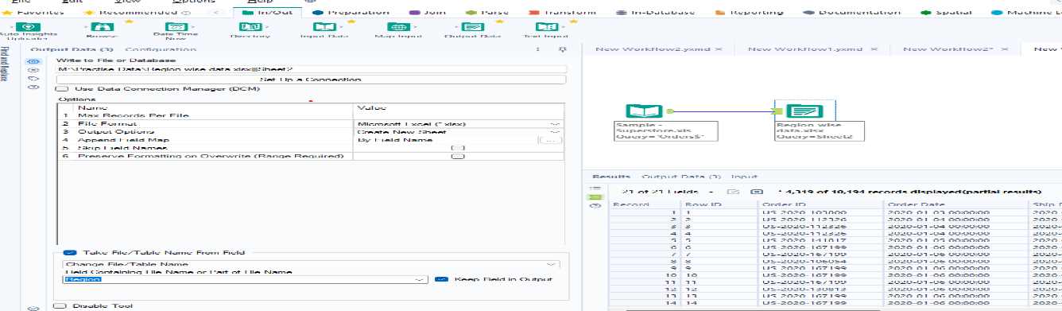

From above pic we have to click Take File/Table Name from Field and change the field name below the we can get separate sheets as row values.

Same procedure for Databases also

**BROWSE TOOL:**

Each Anchor has a capacity of display 1MB data only it cant display more than 1 MB data for one Anchor so we used Browse tool to see the all the records

Profiling information also given by browse tool

If you to Disable all Browse tools click on white space go to Runtime Disable all browse tools

If your workflow is very slow then go to Runtime there we have option Use specific Amount Data there we can increase by default it is having 4GB but its

If you want to see total data before processing same procedure like disable total output data tools then make sure data before seeing the output run

To see the path and all click on cell viewer in result window

When there is colors in the results panel regarding NULL,space and values

Green(OK): The column contains values without leading or trailing white spaces.

Red(Not OK): The columns values with leading or trailing white space.

Yellow(NULL): The column contains no values-It means undefined

Gray(Empty): The column contains strings with no values-means its empty

**MAP INPUT:** Data type is spatial object

**CONV ERROR:** When tryingto convert data type and its not a valid conversion then it will through an error for example trying to convert V_String to Double then it through COnV error

By default it show only 10 CONV Errors to increase this In runtime we have to change

**Data Types:** Byte---0,1,2,3,4,………255

Int16—(32,768 to 32767)

Int32---(-2147483648 to 2147483647)

Int64---(9223372036854 to -9223372036854)

FixedDecimal---only range is difference here 7

Double---15

Difference between string and V_string(Variable String) and WString(Wide range string)

String is fixed one like if you give 15 memory it Is wastage

V_string will save the memory it will occupy only how much it wants

If you want to remove NULL rows and NULL columns then we should go for Data cleansing there we can check Remove NULL rows and Remove NULL Columnms and here itself having Replace string NULLS with blanks and int NULLS with ‘0’. And also check Leading and trailing whitespace and also can change UPPER,LOWER these all the things can do by customizing the columns if you want to do separate columns then again drag and drop another Data cleansing tool

If we want to remove letters and numbers we can do in Data Cleansing

In Filter tool we have two options T an F

Which satisfy the condition it goes to T rest go to F

For between we can do col1>=3000 and col1<=5000

When come to dates we can filter like start date from 10,20….. days

In formula tool we can update data type for formula column but we cant change for existing column

If day column like having 1,2,3……. Need to change to date format then write formula like create one column write formula like dateTimeAdd(‘’1900-01-01”,[Field1],”Days”)

In SELECT statement we can change data type and rename the column

If there is multiple fields need to apply same logic then we go for multi field formula

**MULTI FIELD FORMULA:** Whenever you want to apply common condition to all the field then we can go for this suppose if there is JAN to DEC months you want to apply condition for to all the months then we can go for Multi Field formula.

ERROR like Few numbers are truncated means size of datatype not enough need to increase

Whenever you want to access multiple rows we called as MultiROW formula

If we want AVERAGE then in Multi row formula we have to increase Num Rows to -1,-2,-3…….there we can select the values and do /3,4,……….

While sorting if we want to sort numbers in string format then we have check Dictionary order

To get the word from the any sentence In formula tool we write Getword(col1,0) it starts from 0

If we need some % of data then we go for Sample tool here we are having options like first N rows, Last N rows, skip 1st N rows,1 of every N rows, First % of rows

If we want sample % records then we have to go for

Auto Field automatically create perfect adatabyte and size if not satisfy go for select tool

Imputation tool replace NULL value with AVG or Median,mode or custom value for specified column we can replace not only with Null we can replace any value with any one

Imputation works with only Integers not work strings

**TILE:** It is like rank and group by function in SQL

**QUESTIONS:**

1. Remove Null columns and NULL record
2. Remove records which don’t have Customerid
3. Replace currency symbol in amount filed to make it number
4. Replace missing score with 0
5. Convert amount to number
6. Increase score and amount by 10%
7. Replace missing US amount with average value and maintain the sequence of records
8. Convert all amount to $
9. Duplicate the record for each date
10. Take cumulative sum for each country
11. Store each country results in separate file

**Generate Rows:** It will giverepititivevalues like for loop while loop

**TRANSFORM tool**: Is used to convert rows.

If we don’t want to see null in a column we can go for **filter** tool option

If we want replace any symbol then go for formula and write query like

Replace(column name, ‘$’,” “)

For above if we want replace multiple symbols the go for

If contains(columnname,”$”) then Replace(columnname,”$”,” “) elseif repeat endif

Imputation tool used to replace null with user defined value it works faster than formula tool

**JOINS:** In Alteryx if we go for join concept Inner join works as same as SQL

Comes to left outer join it wont display common record it displays only unmatched records from Left Table

Comes to Right outer join it wont display common record it displays only unmatched records from Right table

LEFT RIGHT INNER LEFT RIGHT

1 1 1 2 4

1 1 1

2 3 1

3 4 1

3

We can join in another model also like Join by Record position

|  |  |  |  |  |  |  |  |
| --- | --- | --- | --- | --- | --- | --- | --- |
| LEFT | RIGHT |  | INNNER | |  | LEFT | RIGHT |
| 1 | 1 |  | 1 | 1 |  |  | 0 |
| 1 | 1 |  | 1 | 1 |  |  | 8 |
| 2 | 3 |  | 2 | 3 |  |  |  |
| 3 | 4 |  | 3 | 4 |  |  |  |
| 1 | 1 |  | 1 | 1 |  |  |  |
| 6 | 9 |  | 6 | 9 |  |  |  |
| 7 | 3 |  | 7 | 3 |  |  |  |
|  | 0 |  |  |  |  |  |  |
|  | 8 |  |  |  |  |  |  |

If we want to join more than two tables we can go for Join Multiple tool

If we to join more number of duplicate records it will through error still want continue then go for Allow All multidimensional joins

In Alteryx by default having Union ALL

If the field are not in proper or different field names then go for manual

In UNION

**Append tool** is the best example for the CROSS join

**VLOOKUP:** If we wantto replace one table column data into another table column data the we use pivot table

Col1 Col1 Col2

A A 10

B B 20

C E 30

D F 40

When we apply VLOOkUP then output will be A,B with values

In **Find&Replace** tool we get the desired output

**FUZZYMATCH** tool it will give the probable result of matched result set

**Make Group tool:** By using this tool we can group based on their relationship like employee and manager relation generally it is used in fuzzy matched tool